Staff Profile
Name: ARDRA. B  Designation: Assistant Professor,Department of Science and Humanities.  Email: arrdra@gmail.com | 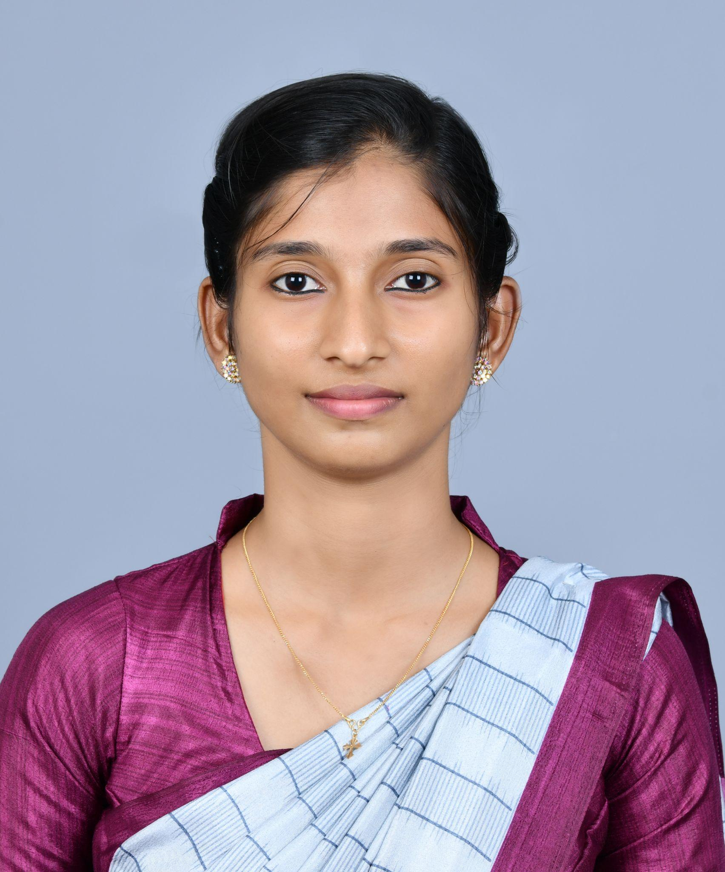
Qualifications:
- M.A. in English Language and Literature
- UGC NET

Specializations :
- Life Skills Education

- Indian English Literature

- Feminist and Rural Narratives

- Cultural Studies

Biography:

Ardra B completed her Post Graduation in English Language and Literature from Sree Sankaracharya University of Sanskrit, Kerala, and her Undergraduate Programme in English and Communicative English from the University of Kerala. She qualified UGC NET and began her academic career in 2023 as a Guest Lecturer in English. Her teaching areas include Life Skills and Professional Communication.

Her academic interests encompass Indian English Literature, Caste Studies, Marginal Voices in Literature, Malayalam Literature in English Translation, and Cultural Studies. She has presented research papers at national and international seminars on themes related to gender, caste, ecocriticism, and Indian literature.

A university rank holder in her Master's programme, Ardra is also a published writer and co-author of several anthology publications. She is passionate about literary research, writing, and exploring the intersections between literature, culture, and society.

Present Responsibilities
- Teaching Life Skills, and Professional Communication

- Supporting Literary and Cultural Activities

- Serving as S1 CSE Staff Advisor

Area of interest
- Feminist Literary Criticism and Women’s Writing

- Retellings of Indian Myths and Epics

- Caste, Culture, and Marginal Voices in Literature

- Rural Representations in Indian Writing

Publications
1. Dreams Woven for Tomorrow (ISBN 9789391280862) – Co-author

2. Lullaby in Safe Arms (ISBN 9789354811166) – Co-author

3. My Eternal Fairytale (ISBN 9788119538102) – Co-author

4. Cotton Candies (ISBN 9789392198793) – Co-author

5. Fantasy Heals Reality (ISBN 98938406691) – Co-author

Paper presentations
-Presented a topic on Trapped in Tradition: Internalized Misogyny and Triple Oppression in One Part Woman at the International Conference on Arts, Literature, and Business (ICALB) organized by Government College Kattappana, Mahatma Gandhi University, Kottayam, on November 29, 2024.

Presented a topic on "Ecocritical Perspectives on Human-Animal Boundaries in Fandry" at the National Symposium organized by Sahitya Akademi and All Saints' College, Thiruvananthapuram, on October 30, 2024.
-Presented a topic on "A Subversive Retelling of the Sanskrit Epic" at a Three-Day National Seminar organized by Sree Sankaracharya University of Sanskrit, Thuravoor Regional Campus, in 2023.

Workshop

Completed Workshop on 'Life Skills’ by HRDC, of the University on 10th March 2026 at College of Engineering Trivandrum.

Achievements

*5th Rank in M.A. English

*Presented research papers on Indian literature, gender studies, ecocriticism, and reinterpretation of Sanskrit epics

*Participated in National Youth Festival 2023 and won prizes in university-level competitions

*Recipient of Aspire Research Award 2022 for M.A. students

*Won Thusharam Samskarika Award in 2014 for short story writing

